**General Awareness / Familiarization Training**

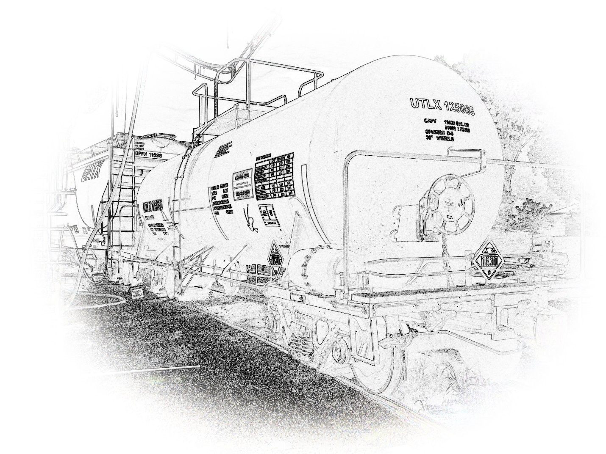

**A Training Program For HazMat Employees**

***General Awareness & Familiarization Training***

**1. Introduction**

**Part 172 Subpart H** of the Hazardous Materials Regulations sets training requirements for individuals involved in all modes of transportation (over-the- road, rail, aircraft or vessel) of hazardous materials. The purpose is to ensure that hazmat employers train their hazmat employees regarding safe practices in the following areas:

* Loading and unloading
* Handling
* Storing
* Transporting
* Emergency preparedness to accidents involving hazardous materials.

Two key definitions of the Hazardous Materials Regulations are:

**Hazmat Employer**

* A company/person who utilizes one or more employees to transport or cause to transport, hazardous materials in commerce, or
* One who represents, marks, certifies, sells, offers, reconditions, tests, repairs, or modifies containers, drums, or for use in trans- porting hazardous materials.
* This includes:
  1. Owners and operators of vehicles that transport hazardous materials.
  2. Any department or agency of the United States.
  3. A State or political subdivision of a State
  4. An Indian tribe that deals with hazardous material as a form of business.

**Hazmat Employee**

* One who directly affects the safe transportation of hazardous materials, either as a self-employed person or one who performs duties relating to hazardous materials as part of the job.
* This includes the owner/operator of a motor vehicle that transports hazardous materials in commerce.

Based on these definitions, workers who must be trained include those who:

* Load or unload hazardous materials
* Test, recondition, repair, modify, or mark containers, drums or packaging used in transporting hazardous materials
* Prepare hazardous materials for transporting
* Are responsible for the safe transporting of hazardous materials [supervisors, for example), or
* Operate a vehicle transporting hazardous materials.

**General Awareness/Familiarization Training will:**

* Increase your awareness of the purpose of the Hazardous Materials Regulations and of the hazard communication requirements.
* Ensure that everyone involved in the transportation of hazardous materials uses uniform procedures.

**3 ways a hazmat incident could occur at this facility:**

1. A leak or malfunction of hose during off-loading at railcar
2. A leak or breakage of the transfer pipe between railcar and storage tank
3. A leak or rupture at storage tanks

**2. The Hazardous Materials Table**

The Hazardous Materials Table lists materials that the Research and Special Programs Administration has determined*: may pose an unreasonable risk to health and safety or property when transported in commerce.*

The Hazardous Materials Table identifies the requirements that apply to each shipment of a hazardous material. The table will help the user identify:

* proper classification, including: hazard class, identification number, and packing group (PG)
* label codes
* special provisions
* packaging authorizations
* quantity limitations by air
* vessel stowage requirements

***What the Hazardous Materials Table shows***

|  |  |  |  |  |  |  |  |  |  |  |  |  |  |  |  |
| --- | --- | --- | --- | --- | --- | --- | --- | --- | --- | --- | --- | --- | --- | --- | --- |
| **§172.101 Hazardous Materials Table** | | | | | | | | | | | | | | | |
|  |  |  |  |  |  |  | **Packaging (§173.***)** | | | **Quantity limitations (see §§173.27 and 175.75)** | | | **10 Vessel Stowage** | | |
| **Symbols** | **Hazardous materials descriptions and proper shipping names** | **Hazard class or Division** | **Identification Numbers** | **PG** | **Label Codes** | **Special provisions (§172.102)** | **Exceptions** | **Non-bulk** | **Bulk** | | **Passenger aircraft/rail** | **Cargo aircraft only** | | **Location** | **Other** |
| 1 | 2 | 3 | 4 | 5 | 6 | 7 | (8A) | (8B) | (8C) | | (9A) | (9B) | | (10A) | (10B) |
|  | **Sulfuric acid** *with more than 51 percent acid* | **8** | **UN1830** | **ii** | 8 | A3, A7, B3, B83, B84, IB2, N34, T8, TP2 | 154 | 202 | 242 | | 1L | 30L | | C | 14 |

Here is a brief review of the information found in each column of this table:

**Column 1 – Symbols**

Six (6) symbols showing special conditions placed on hazardous materials.

1. The plus symbol "**+**" fixes proper shipping name, hazard class and packing group without regard to whether the material meets that class, packing group or my other hazard class.
2. The letter "**A**" applies to materials offered or intended for transportation by aircraft unless the material is a hazardous substance or a hazardous waste.
3. The letter "**D**" identifies proper shipping names for describing material for domestic transportation- may be inappropriate for international transportation.
4. The letter **"G"** identifies proper shipping names for which one or more technical names of the hazardous material must be entered in parentheses, in association with the basic description.
5. The letter **"I**" identifies proper shipping names for describing materials in international transportation.
6. The letter "**W**’ applies to materials offered or intended for transportation by vessel unless the material is a hazardous substance or a hazardous waste.

**Column 2 - Hazmat Descriptions and Proper Shipping Names**

Lists those materials designated as hazardous. Use column 2 to find the proper shipping name of the hazardous material to be shipped or the name that most accurately describes the material. Proper shipping names appear in Roman type not *italics.*

If the user believes the material is not covered in the table, contact:

Office of Hazardous Materials Standards

Research and Special Programs Administration

U.S. Department of Transportation

400 Seventh Street, S.W. Washington, D.C. 20590

(202) 366-4488

**Column 3 - Hazard Class/Division**

Designates the hazard class and/or division of each proper shipping name, or the word Forbidden. If *Forbidden*, the material may not be transported unless diluted, stabilized or incorporated in a device and classed according to the definitions in the *Hazardous Materials Regulations.*

**Column 4 - Identification Numbers**

Contains the identification numbers assigned to each proper shipping name.

a. **"UN"** (United Nations) indicates that the material is appropriate for international and domestic transportation.

b. **"NA"** (North American) indicates that the material is appropriate for domestic and Canadian transport only.

**Column 5 - PG (Packing Group)**

Packing groups indicate the degree of danger the material presents:

* I - great danger
* II- medium danger
* III - minor danger

**Column 6 - Label Codes**

Shows the code(s) for the proper hazard warning labels to be used.

**Column 7 - Special Provisions**

Identifies special provisions.

* + - Provisions identified by a number apply only to materials that can be transported by several modes in both bulk and non-bulk packaging.
* Provisions identified by a letter apply to specific modes of transportation or to bulk or non-bulk packaging.

**Column 8 – Packaging**

This column contains three types of packaging authorizations: exceptions, non- bulk, and bulk.

**Column 9 - Quantity Limitations**

Lists maximum quantities that can be transported in one package via:

* Passenger-carrying aircraft
* Passenger-carrying rail car
* Cargo aircraft

**Column 10 - Vessel Stowage**

Identifies where the material can be stowed on-board both passenger and cargo vessels.

For more information, the Hazardous Materials Table can be found in Part 172 of the Hazardous Materials Regulations.

# 3. **Shipping Papers**

Whenever a hazardous material is transported, its description must appear on the shipping paper.

The description must adhere to these requirements:

1. If a hazardous material and a non-hazardous material are described on the same shipping paper, the hazardous material must be:
2. listed first, or
3. shown in a contrasting color (highlighted on multi-page form), or
4. identified with an **"X"** or **"RQ"** before the proper shipping name in the column marked **"HM."**
5. Entry must be legible and printed in English.
6. Unless specifically authorized or required, the description may not contain codes or abbreviations.
7. Additional information must follow the basic description.
8. Must contain the name of the shipper.
9. If more than one page is required, the first page must indicate such. For example, ‘page 1 of 4’.
10. Shipping paper must show an emergency response telephone number.

***Note:*** *An emergency response telephone number is not required for limited quantities and many miscellaneous materials.*

1. Shipping paper must contain shipper's certification.

A shipping description must include:

* Proper shipping name
* Hazard class or division (column 3, Hazardous. Materials Table)
* Identification number (column 4, Hazardous Materials Table)
* Packing group (column 5, Hazardous Materials Table)
* Except for empty packaging, the total quantity, including unit of measurement, of the hazardous material.

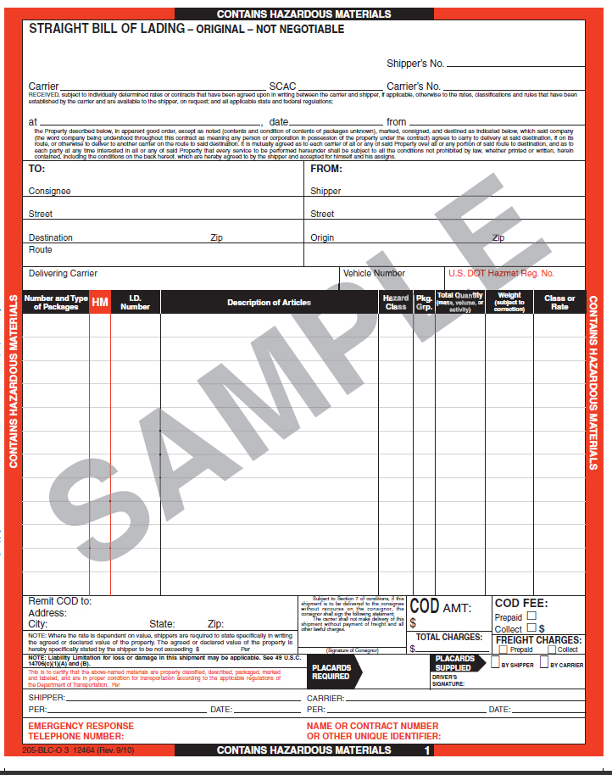

Complete instructions for shipping papers appear in Part 172 of the Hazardous Materials Regulations, Subpart C.

**4. Labeling of a Hazardous Material**

Hazardous Material Warning Labels are designed and color-coded so that the hazards can be quickly recognized. Warning labels correspond to the placards that must appear on each bulk packaging, freight container, unit load device, transport vehicle or rail car that contains a hazardous material. The labels must include both the hazard class and the division of hazard, if required, according to the Hazardous Materials Table. Unless excepted, all hazardous material packages must be labeled.

Warning label codes can be found in column 6 of the Hazardous Materials Table. Use the Label Substitution Table to identify the label name for the code(s) ' listed in Column 6.

* The first code listed is the primary hazard of the material.
* Additional codes indicate subsidiary hazard(s).

**§172.422 SPONTANEOUSLY COMBUSTIBLE label**

(a) Except for size and color, the SPONTANEOUSLY COMBUSTABLE label must be as follows:

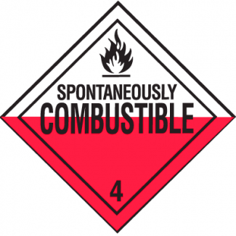

(b) In addition to complying with §172.407 of this subpart, the background color on the lower half of the SPONTEOUSLY COMBUSTIBLE label must be red and the upper half must be white.

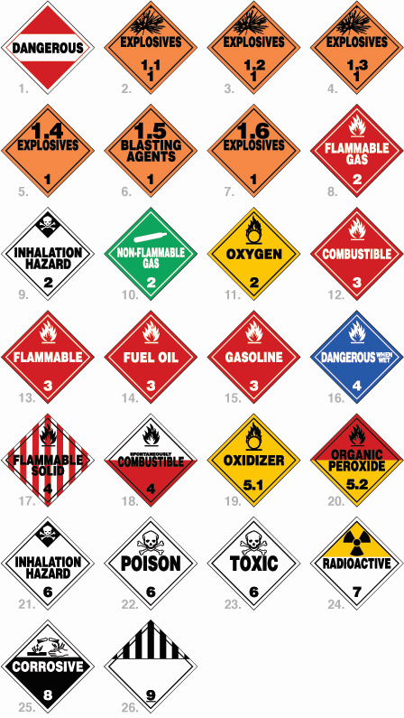

Three common hazardous materials that may be transported to this facility and their required label(s) for each.

**Hazardous Material** **Proper Warning Label**

**Sulfuric Acid Corrosive #8**

**Fragrance Flammable #3**

**Propane Flammable Gas #2**

**5. Performance Oriented Packaging**

The proper packaging of hazardous materials is crucial to the safety of everyone involved in their handling and transport.

A performance oriented package must perform in a safe manner under normal transportation conditions.

The requirements refer to:

* bulk and non-bulk packaging
* new and reused packaging
* specification and non-specification packaging

Each hazmat package must be designed and manufactured so that when it is filled to its limits, closed, and under normal transportation conditions:

* there will be no identifiable release of hazardous materials
* there will be no reduction in package effectiveness (i.e. impact resistance, strength) due to variations in temperature
* there will be no mixture of gases/vapors in the package that could reduce package effectiveness

Packaging cannot be used for hazardous material transportation unless they:

a. Meet the above requirements

b. Are properly marked with ID numbers and special requirements

c. Are tested and approved prior to use

d. Have a manufacture’s mark on each package

The following is an example of the amount of information that can be obtained from the manufacturer's marking on the package.

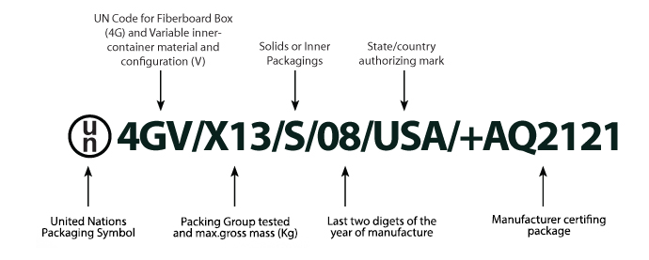

**Specific instructions for all types of packaging and all modes of transportation can be found in the Hazardous Material Regulations, Part 173: Shippers General Requirements for Shipments and Packaging.**

**6. Proper Loading and Storage Techniques**

The responsibility for complying with the provisions for loading, storage, and transportation of hazardous materials generally lies with the carrier.

Specific information on loading and storing hazardous material containers for all modes of transportation is located in the Hazardous Materials Regulations Part 177, Carriage by Public Highway, Subpart B: Loading and Unloading, specifies loading and storing requirements for motor vehicles.

There are two requirements of Part 177 that are of special importance:

* **Separation distances** are established for transporting radioactive materials and are also required for people and cargo compartment dividing petitions.

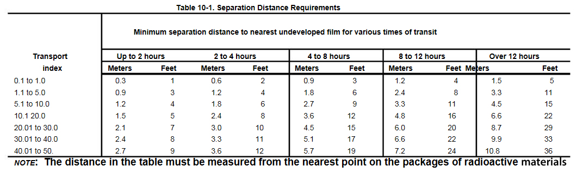

* 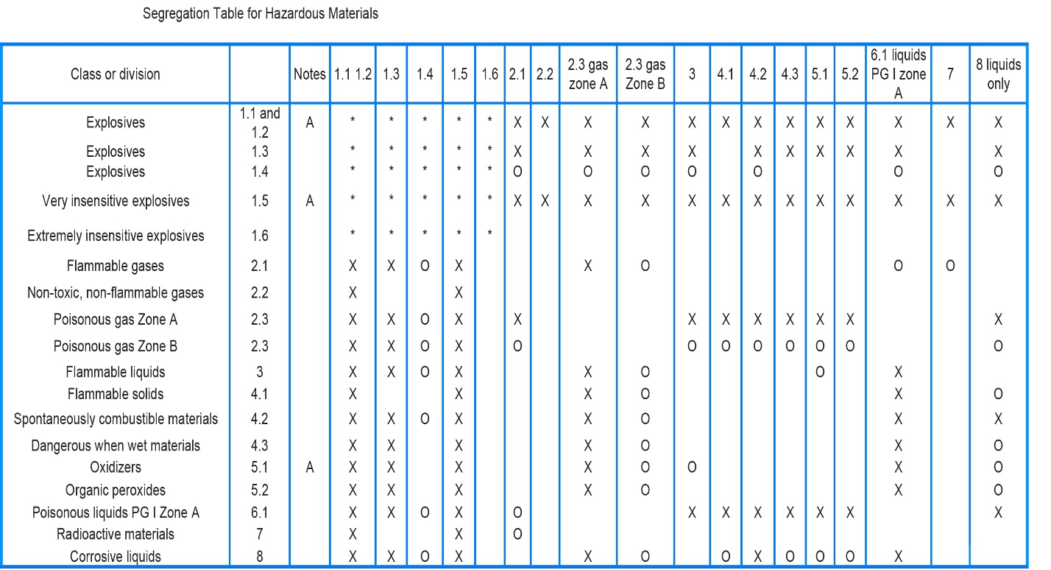**Segregation of Hazardous Materials.** Certain hazardous materials cannot be carried on the same load. For example, cyanides or cyanide mixtures cannot be transported with acids. A Segregation Table provides a reference for segregating certain hazardous materials.

**7. Proper Placarding**

Hazmat placards are similar to the shape, color and design of hazmat warning labels. They serve the following functions:

* to alert the public to the potential dangers of hazardous materials
* to guide emergency personnel in their actions during a hazmat incident

Unless excepted, each bulk packaging, freight container, unit load device, transport vehicle or rail car containing any quantity of a hazardous material must be placarded on each side and each end with the placards specified in Part 172, Subpart F.

**49 CFR Section 172.504 Table 1**

|  |  |  |
| --- | --- | --- |
| Category of material (Hazard class or division number and additional description, as appropriate) | Placard name | Placard design section reference (§) |
| 1.1 | [[http://www.labelmaster.com/product/image/PSR40.jpg](http://www.labelmaster.com/shop/placards/hazard-class-1-placards/explosive-1-1-placards/) EXPLOSIVES 1.1](http://www.labelmaster.com/shop/placards/hazard-class-1-placards/explosive-1-1-placards/) | 172.522 |
| 1.2 | [[http://www.labelmaster.com/product/image/PSR50.jpg](http://www.labelmaster.com/shop/placards/hazard-class-1-placards/explosive-1-2-placards/) EXPLOSIVES 1.2](http://www.labelmaster.com/shop/placards/hazard-class-1-placards/explosive-1-2-placards/) | 172.522 |
| 1.3 | [[http://www.labelmaster.com/product/image/PSR60.jpg](http://www.labelmaster.com/shop/placards/hazard-class-1-placards/explosive-1-3-placards/) EXPLOSIVES 1.3](http://www.labelmaster.com/shop/placards/hazard-class-1-placards/explosive-1-3-placards/) | 172.522 |
| 2.3 | [[http://www.labelmaster.com/product/image/Z-PL25.jpg](http://www.labelmaster.com/shop/placards/hazard-class-2-placards/toxic-gas-worded-placards/) TOXIC GAS](http://www.labelmaster.com/shop/placards/hazard-class-2-placards/toxic-gas-worded-placards/) | 172.540 |
| 4.3 | [[http://www.labelmaster.com/product/image/Z-PL23.jpg](http://www.labelmaster.com/shop/placards/hazard-class-4-placards/dangerous-when-wet-worded-placards/) DANGEROUS WHEN WET](http://www.labelmaster.com/shop/placards/hazard-class-4-placards/dangerous-when-wet-worded-placards/) | 172.548 |
| 5.2 (Organic peroxide, Type B, Liquid or solid, temperature controlled) | [[http://www.labelmaster.com/product/image/Z-PL52.jpg](http://www.labelmaster.com/shop/placards/hazard-class-5-placards/organic-peroxide-worded-placard-revised/) ORGANIC PEROXIDE](http://www.labelmaster.com/shop/placards/hazard-class-5-placards/organic-peroxide-worded-placard-revised/) | 172.552 |
| 6.1 (material poisonous by inhalation (see § 171.8 of this subchapter)) | [[http://www.labelmaster.com/product/image/Z-PL29.jpg](http://www.labelmaster.com/shop/placards/hazard-class-6-placards/inhalation-hazard-worded-placards/) POISON INHALATION HAZARD](http://www.labelmaster.com/shop/placards/hazard-class-6-placards/inhalation-hazard-worded-placards/) | 172.555 |
| 7 (Radioactive Yellow III label only) | [[http://www.labelmaster.com/product/image/Z-PL7R.jpg](http://www.labelmaster.com/shop/placards/hazard-class-7-placards/radioactive-worded-placards/) RADIOACTIVE(1)](http://www.labelmaster.com/shop/placards/hazard-class-7-placards/radioactive-worded-placards/) | 172.556 |
| (1) RADIOACTIVE placard also required for exclusive use shipments of low specific activity material and surface contaminated objects transported in accordance with § 173.427(b)(4) and (5) or (c) of this subchapter. | | |
| |  |  |  | | --- | --- | --- | | **49 CFR Section 172.504 Table 2**  Category of material (Hazard class or division number and additional description, as appropriate) | Placard name | Placard design section reference (§) | | 1.4 | [[http://www.labelmaster.com/product/image/PSR72-SP.jpg](http://www.labelmaster.com/shop/placards/hazard-class-1-placards/explosive-1-4-placards/) EXPLOSIVES 1.4](http://www.labelmaster.com/shop/placards/hazard-class-1-placards/explosive-1-4-placards/) | 172.523 | | 1.5 | [[http://www.labelmaster.com/product/image/PSR81.jpg](http://www.labelmaster.com/shop/placards/hazard-class-1-placards/explosive-1-5-d-placards/) EXPLOSIVES 1.5](http://www.labelmaster.com/shop/placards/hazard-class-1-placards/explosive-1-5-d-placards/) | 172.524 | | 1.6 | [[http://www.labelmaster.com/product/image/PSR90.jpg](http://www.labelmaster.com/shop/placards/hazard-class-1-placards/explosive-1-6-n-placards/) EXPLOSIVES 1.6](http://www.labelmaster.com/shop/placards/hazard-class-1-placards/explosive-1-6-n-placards/) | 172.525 | | 2.1 | [[http://www.labelmaster.com/product/image/Z-PL8.jpg](http://www.labelmaster.com/shop/placards/hazard-class-2-placards/flammable-gas-worded-placards/) FLAMMABLE GAS](http://www.labelmaster.com/shop/placards/hazard-class-2-placards/flammable-gas-worded-placards/) | 172.532 | | 2.2 | [[http://www.labelmaster.com/product/image/Z-PL3.jpg](http://www.labelmaster.com/shop/placards/hazard-class-2-placards/non-flammable-gas-worded-placards/) NON-FLAMMABLE GAS](http://www.labelmaster.com/shop/placards/hazard-class-2-placards/non-flammable-gas-worded-placards/) | 172.528 | | 3 | [[http://www.labelmaster.com/product/image/Z-PL2.jpg](http://www.labelmaster.com/shop/placards/hazard-class-3-placards/) FLAMMABLE](http://www.labelmaster.com/shop/placards/hazard-class-3-placards/) | 172.542 | | Combustible Liquid | [[http://www.labelmaster.com/product/image/Z-PL9.jpg](http://www.labelmaster.com/shop/placards/hazard-class-3-placards/combustible-liquid-worded-placards/) COMBUSTIBLE](http://www.labelmaster.com/shop/placards/hazard-class-3-placards/combustible-liquid-worded-placards/) | 172.544 | | 4.1 | [[http://www.labelmaster.com/product/image/Z-PL13.jpg](http://www.labelmaster.com/shop/placards/hazard-class-4-placards/flammable-solid-worded-placards/) FLAMMABLE SOLID](http://www.labelmaster.com/shop/placards/hazard-class-4-placards/flammable-solid-worded-placards/) | 172.546 | | 4.2 | [[http://www.labelmaster.com/product/image/Z-PL21.jpg](http://www.labelmaster.com/shop/placards/hazard-class-4-placards/spontaneously-combustible-worded-placards/) SPONTANEOUSLY COMBUSTIBLE](http://www.labelmaster.com/shop/placards/hazard-class-4-placards/spontaneously-combustible-worded-placards/) | 172.547 | | 5.1 | [[http://www.labelmaster.com/product/image/Z-PL6.jpg](http://www.labelmaster.com/shop/placards/hazard-class-5-placards/oxidizer-worded-placard/) OXIDIZER](http://www.labelmaster.com/shop/placards/hazard-class-5-placards/oxidizer-worded-placard/) | 172.550 | | 5.2 (Other than organic peroxide, Type B, liquid or solid, temperature controlled) | [[http://www.labelmaster.com/product/image/Z-PL52.jpg](http://www.labelmaster.com/shop/placards/hazard-class-5-placards/organic-peroxide-worded-placard-revised/) ORGANIC PEROXIDE](http://www.labelmaster.com/shop/placards/hazard-class-5-placards/organic-peroxide-worded-placard-revised/) | 172.552 | | 6.1 (other than material poisonous by inhalation) | [[http://www.labelmaster.com/product/image/Z-PL5.jpg](http://www.labelmaster.com/shop/placards/hazard-class-6-placards/poison-worded-placards/) POISON](http://www.labelmaster.com/shop/placards/hazard-class-6-placards/poison-worded-placards/) | 172.554 | | 6.2 |  |  | | 8 | [[http://www.labelmaster.com/product/image/Z-PL4.jpg](http://www.labelmaster.com/shop/placards/hazard-class-8-placards/) CORROSIVE](http://www.labelmaster.com/shop/placards/hazard-class-8-placards/) | 172.558 | | 9 | [[http://www.labelmaster.com/product/image/Z-PL19.jpg](http://www.labelmaster.com/shop/placards/hazard-class-9-placards/) Class 9 (see 172.504(f)(9))](http://www.labelmaster.com/shop/placards/hazard-class-9-placards/)+ | 172.560 | | | |

**8. Dealing with a Hazmat Emergency**

Knowing how to respond to a hazmat emergency is crucial. At a minimum this section refers to having emergency response information available at all times during the handling and transportation of a hazardous material. This training is not intended for those hazmat employees whose primary function is emergency response. It is simply meant to provide basic safety training to those with limited emergency responsibilities. See the *Spill Response Plan* for your respective facility.

This information must include:

* the basic description and technical name of the hazardous material
* immediate hazards to health
* risks of fire and exposure
* immediate precautions to be taken in the event of an incident/accident
* initial methods for handling spills or leaks in the absence of fire
* preliminary first aid measures
* an emergency response phone number

These items must be printed in English and available away from the package containing the hazardous materials, for example on the shipping paper, the North-American Emergency Response Guide book, or Safety Data Sheets.

***Note:*** This section refers to information location and availability and does not mean that all hazmat employees must know how to perform all of the activities listed.

**More information on this subject can be found in the Hazardous Materials Regulations, Part 172, Subpart G: Emergency Response Information.**